# 

# **Final Project Report**

# **EKART – ECOMMERCE WEBSITE**



**DEPARTMENT OF COMPUTER SCIENCE**

**ITCS 6112 – Software System Design & Implementation**

**Submitted To - Dr. Ali Sever**

**Submitted By**

|  |  |  |
| --- | --- | --- |
| **Kowshik Prasad Navilur** | **Medha Nagaraj** | **Prerana Chandrashekhar** |
| **801072936** | **801101751** | **801082232** |

**EKART - Table of Contents**

|  |  |
| --- | --- |
| **1. PROJECT DESCRIPTION** | |
| **1.1 Overview** | **3** |
| **1.2 Problem Statement for E-Commerce Application** | **3** |
| **1.3 Proposed System** | **3** |
|  |  |
| **2. SOFTWARE REQUIREMENTS SPECIFICATION** | |
| **2.1 Functional requirements** | **4** |
| **2.2** **System Constraints** | **4** |
| **2.3 Data processing / analysis requirement** | **4** |
| **2.4 Description of the programming part of project** | **5** |
| **2.5 Description of the typical system customers** | **5** |
|  |  |
| **3. USE CASE DIAGRAM** | **6** |
|  |  |
| **4. SEQUENCE DIAGRAM & SYSTEM ARCHITECTURE** | **7** |
|  |  |
| **5. CLASS DIAGRAM & SOFTWARE SYSTEM LIFECYCLE** | **8** |
|  |  |
| **6. OUTPUTS SCREENSHOTS** | **9** |
|  |  |
| **6. CONCLUSION** | **11** |
|  |  |
| **6. REFERENCES** | **12** |

**PROJECT DESCRIPTION**

**1.1 Introduction**

The project is about building an E-commerce website using Python Flask framework. This ecommerce website displays products wherein the Users can Add and Remove products to or from their carts. And at the same time, it also specifies the quantity of each item. The admin has the privileges to add, delete and update the items in the website which is dynamic in nature and presents an open-source outlook to the users.

**1.2 Problem Statement for E-Commerce Application:**

* E-commerce provides an easy way to sell products to a large customer base. However, there is a lot of competition among multiple e-commerce sites. When users land on an e-commerce site, they expect to find what they are looking for quickly and easily.
* Also, users are not sure about the brands or the actual products they want to purchase. They have a very broad idea about what they want to buy.
* Many customers nowadays search for their products on Google rather than visiting specific e-commerce sites. They believe that Google will take them to the e-commerce sites that have their product.
* Establishing a collaborative environment among various project stakeholders has become inevitable. This link is built by our website and provides a communication platform between the company and developers.

**1.3 Proposed System:**

We propose a website which we created using the Python Flask Framework. The website displays products. Users can add and remove products to or from their carts while also specifying the quantity of each item. The website also provides a list of options for users to explore. The features of the project also include the provision wherein the users can give their reviews to items, pay for the item purchased and also explore the feature of creating an account and login / logout.

**SOFTWARE REQUIREMENTS SPECIFICATION**

**2.1 Functional requirements**

* Validate User by asking him to signup and then login based on the username and password
* Display the items, products
* Add/Modify/Delete products
* Add the items to the user’s cart
* Allow the user to modify the information whenever required
* The admin has the access to various functionalities like add/remove user
* Show the stock of the products
* Allow the user to add / delete as many items as required

**2.2 System Constraints**

|  |  |  |
| --- | --- | --- |
| * Programming languages | : | Python (3.7 or above) with flask web framework, HTML, CSS |
| * Operating system | : | Windows 7, Windows 10 |
| * Hardware | : | 4GB RAM, 1.90GHz Processor (dual core) (or higher) |
| * Database | : | SQLite |
| * Web services | : | HTTP |
| * Software tools | : | VS Code, Sublime, SQLite, Web Browser, |

**2.3 Data processing / analysis requirement:**

The data processing in this project is extracting the data from the users in the form of their credentials, payment details, likes and dislikes of the products, purchase history, store them in the SQLite Database and retrieve the data as and when required. The user will be provided a wide range of options of products and details to choose from. Payments will be stored and recorded and will be available as the user’s history. The project is considered a programming project as it involves developing a web interface, smart search, and database system.

**2.4 Description of the programming part of project:**

* E-Commerce is an open source website which uses Django framework and an MVC Architecture depicted and envisioned in the diagram below.
* SQLite is our database to store and retrieve results in the project and displayed to the user through Django
* Technologies Used: Python-Flask, SQLite, HTML, CSS, Bootstrap.

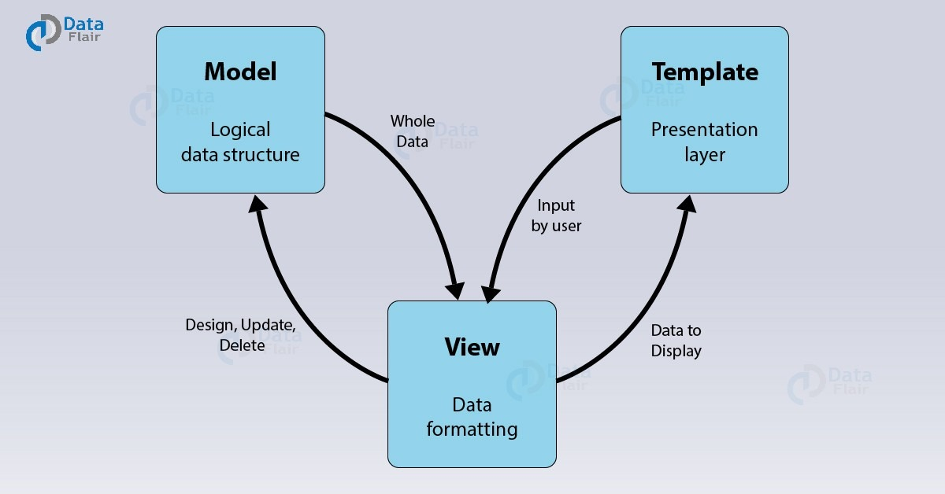

**2.5 Description of the typical system customers:**

* The user initially creates an account
* logs into the website
* goes to the product of his choice
* specifies the quantity of the item needed
* user continues to the payment page
* check out and gets a receipt of the payment made.

**USE CASE DIAGRAM**

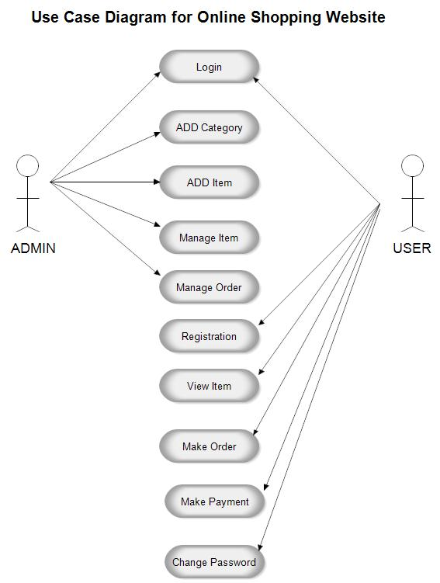

**SEQUENCE DIAGRAM**

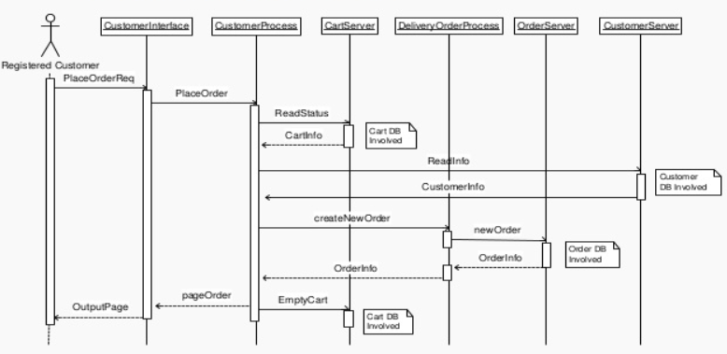

**SYSTEM ARCHITECTURE**

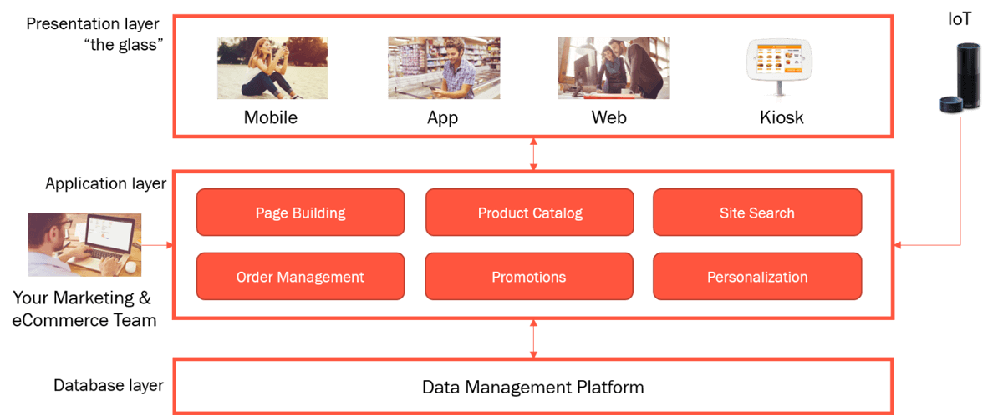

**CLASS DIAGRAM**

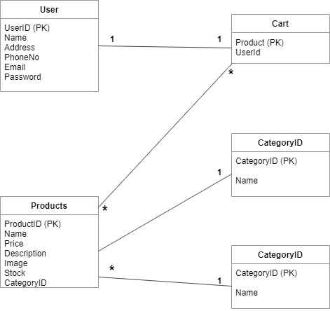

**SOFTWARE SYSTEM LIFECYCLE**

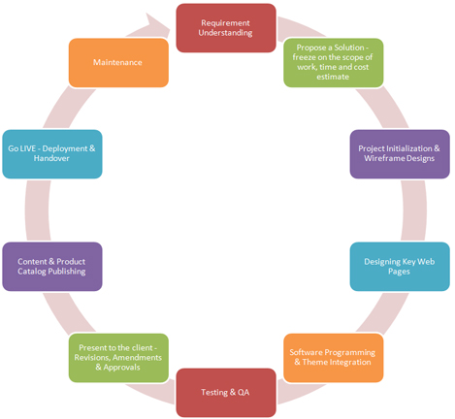

**OUTPUT SCREENSHOTS**

**Below we have the screenshots of the Ecommerce Website – EKART**

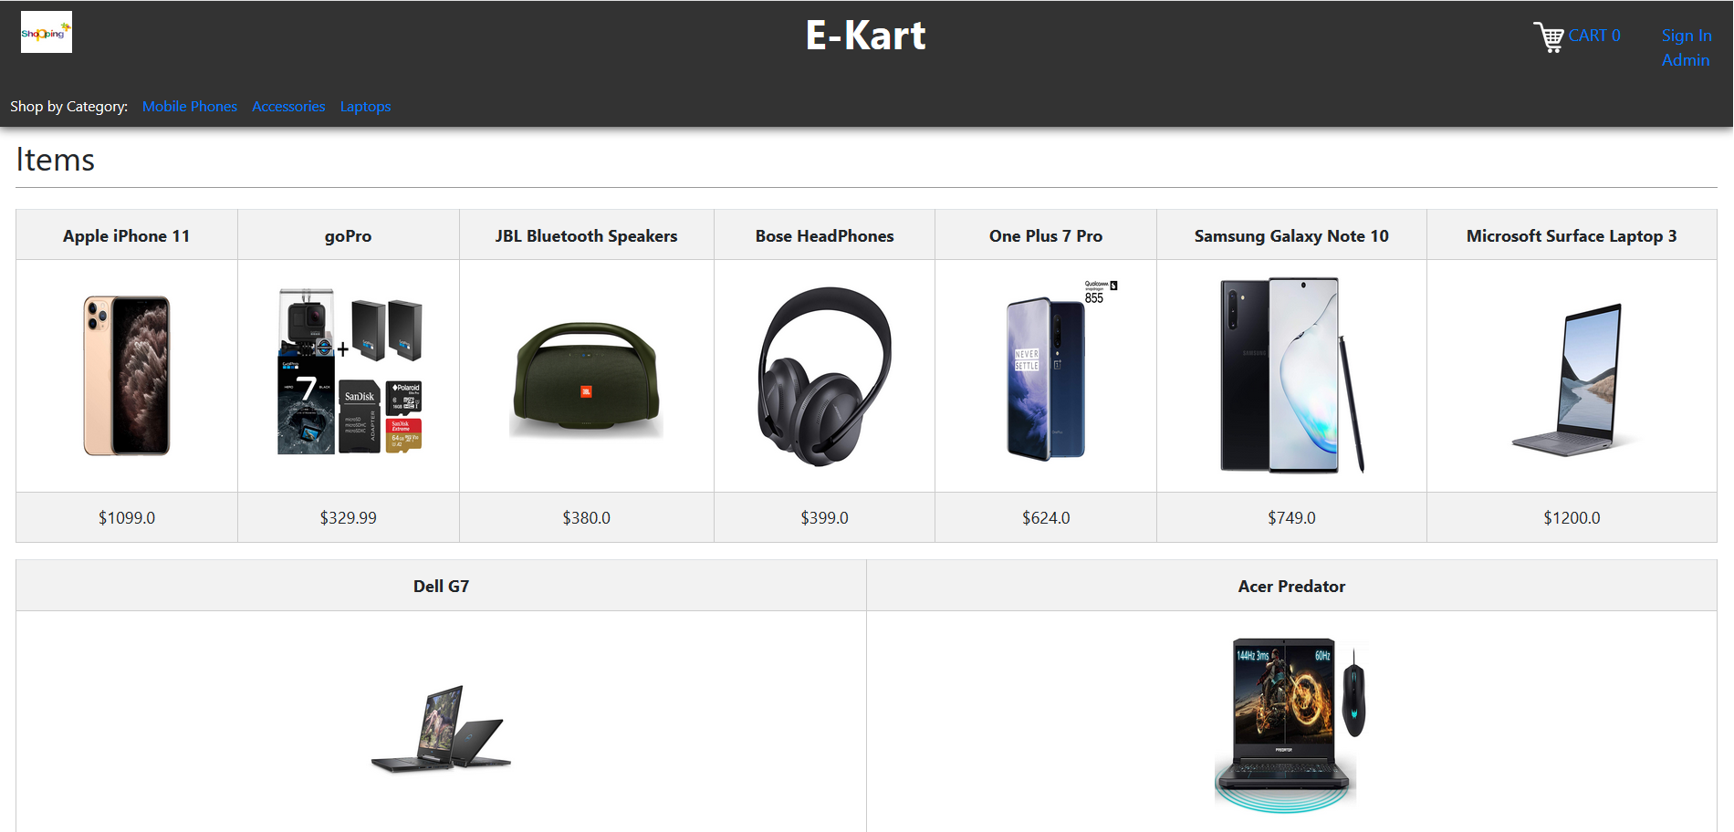

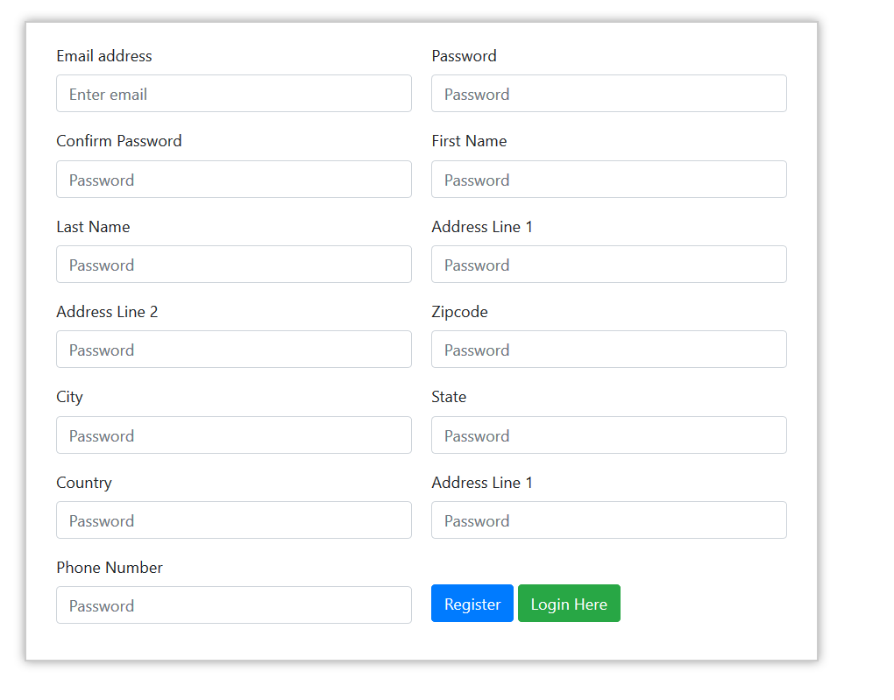

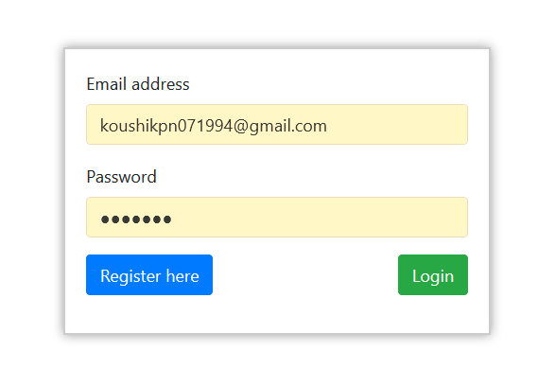

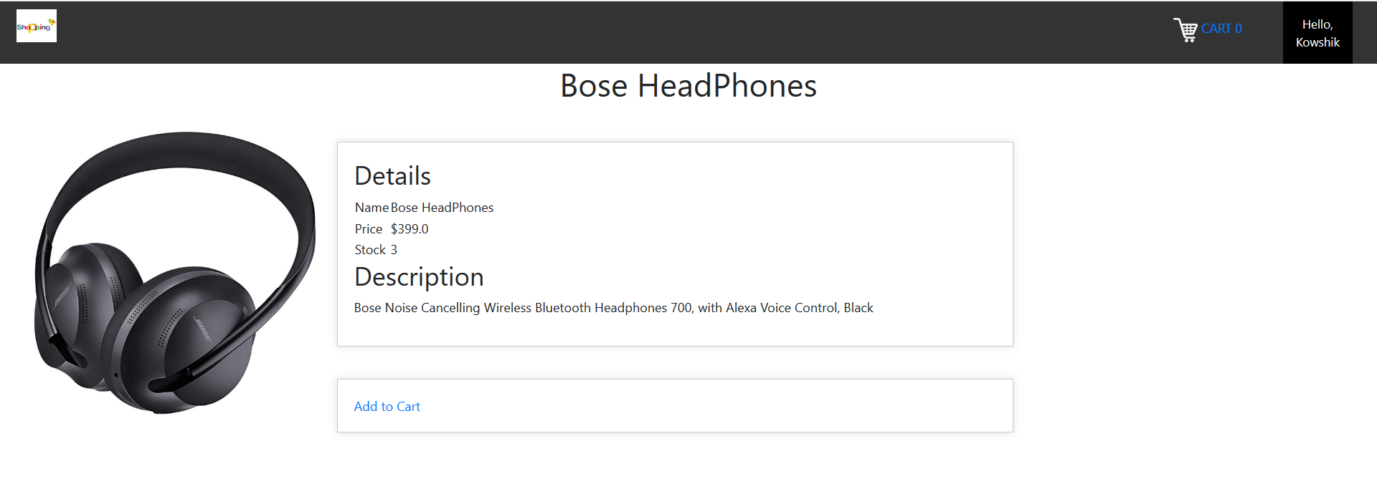

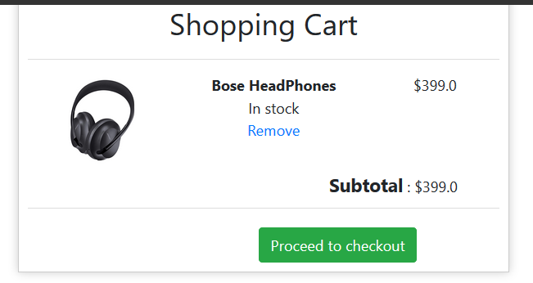

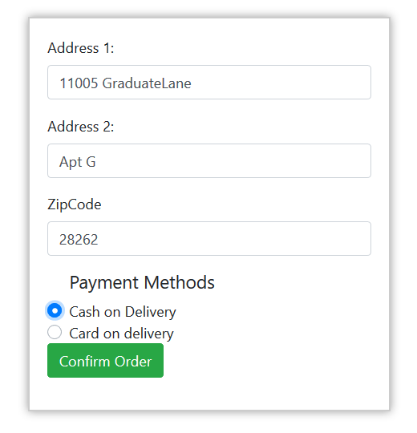

**CONCLUSION**

Through this website we aim at bridging the gap between the admins, system and users.

With the help of ecommerce web design, you get an opportunity to have your products and services available to customers 24 hours.

It gives a good exposure to your business and help you to reach out to potential customers.

With the help of an e-commerce website people can select and buy desired products anytime.

**REFERENCES**

|  |  |  |
| --- | --- | --- |
| **Flask Framework** | : | <https://blog.miguelgrinberg.com/post/the-flask-mega-tutorial-part-i-hello-world> |
| **SQLite** | : | <https://www.sqlitetutorial.net/> |
| **Frontend** | : | <https://www.getbootstrap.com/> |